**Team Project Report**

**Natallia Spell**

**Vaibhav Diwan**

**Analysis of US Companies by Sector**

For the Python bridge course team project, we used a data set from the US Census Bureau which contains statistics for all U.S. firms by Industry, Veteran Status, and Ethnicity for the U.S., States, Metro Areas, Counties, and Places based on the 2012 Survey of Business Owners.   The universe for the 2012 Survey of Business Owners (SBO) includes all U.S. firms operating during 2012 with receipts of $1,000 or more which are classified in the North American Industry Classification System (NAICS).

According to the US Census Bureau website (n.d.), the NAICS classifies the industries into following sectors:

|  |  |
| --- | --- |
| [11](https://www.census.gov/cgi-bin/sssd/naics/naicsrch?chart_code=11&search=2012%20NAICS%20Search) | Agriculture, Forestry, Fishing and Hunting |
| [21](https://www.census.gov/cgi-bin/sssd/naics/naicsrch?chart_code=21&search=2012%20NAICS%20Search) | Mining, Quarrying, and Oil and Gas Extraction |
| [22](https://www.census.gov/cgi-bin/sssd/naics/naicsrch?chart_code=22&search=2012%20NAICS%20Search) | Utilities |
| [23](https://www.census.gov/cgi-bin/sssd/naics/naicsrch?chart_code=23&search=2012%20NAICS%20Search) | Construction |
| [31-33](https://www.census.gov/cgi-bin/sssd/naics/naicsrch?chart_code=31&search=2012%20NAICS%20Search) | Manufacturing |
| [42](https://www.census.gov/cgi-bin/sssd/naics/naicsrch?chart_code=42&search=2012%20NAICS%20Search) | Wholesale Trade |
| [44-45](https://www.census.gov/cgi-bin/sssd/naics/naicsrch?chart_code=44&search=2012%20NAICS%20Search) | Retail Trade |
| [48-49](https://www.census.gov/cgi-bin/sssd/naics/naicsrch?chart_code=48&search=2012%20NAICS%20Search) | Transportation and Warehousing |
| [51](https://www.census.gov/cgi-bin/sssd/naics/naicsrch?chart_code=51&search=2012%20NAICS%20Search) | Information |
| [52](https://www.census.gov/cgi-bin/sssd/naics/naicsrch?chart_code=52&search=2012%20NAICS%20Search) | Finance and Insurance |
| [53](https://www.census.gov/cgi-bin/sssd/naics/naicsrch?chart_code=53&search=2012%20NAICS%20Search) | Real Estate and Rental and Leasing |
| [54](https://www.census.gov/cgi-bin/sssd/naics/naicsrch?chart_code=54&search=2012%20NAICS%20Search) | Professional, Scientific, and Technical Services |
| [55](https://www.census.gov/cgi-bin/sssd/naics/naicsrch?chart_code=55&search=2012%20NAICS%20Search) | Management of Companies and Enterprises |
| [56](https://www.census.gov/cgi-bin/sssd/naics/naicsrch?chart_code=56&search=2012%20NAICS%20Search) | Administrative and Support and Waste Management and Remediation Services |
| [61](https://www.census.gov/cgi-bin/sssd/naics/naicsrch?chart_code=61&search=2012%20NAICS%20Search) | Educational Services |
| [62](https://www.census.gov/cgi-bin/sssd/naics/naicsrch?chart_code=62&search=2012%20NAICS%20Search) | Health Care and Social Assistance |
| [71](https://www.census.gov/cgi-bin/sssd/naics/naicsrch?chart_code=71&search=2012%20NAICS%20Search) | Arts, Entertainment, and Recreation |
| [72](https://www.census.gov/cgi-bin/sssd/naics/naicsrch?chart_code=72&search=2012%20NAICS%20Search) | Accommodation and Food Services |
| [81](https://www.census.gov/cgi-bin/sssd/naics/naicsrch?chart_code=81&search=2012%20NAICS%20Search) | Other Services (except Public Administration) |
| [92](https://www.census.gov/cgi-bin/sssd/naics/naicsrch?chart_code=92&search=2012%20NAICS%20Search) | Public Administration |

**Analysis and Conclusions**

1. **Which sectors are the biggest employers?**

The largest employment sector is Health and Social Assistance, which is closely followed by the Retail Trade sector and the Accommodation and Food Services sector.  By contrast, the Agriculture, Forestry, Fishing and Hunting sector and the Utilities sector have the lowest personnel needs.

These extreme opposites make sense for the following reason:  in the Healthcare and Social Assistance sector, an abundance of human laborers are required to provide treatment and care for individualized patient care, human and animal.  By contrast, the Agricultural sector has become so mechanized that the need for human labor has been so reduced as to constitute the lower relative percentage end.

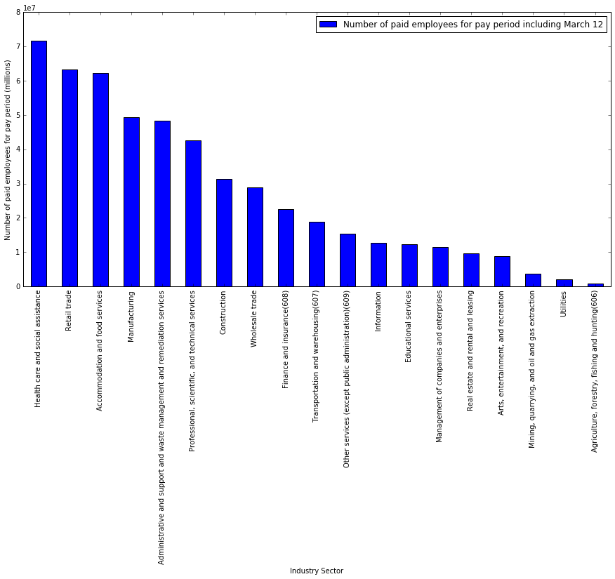

**2. Which sectors (NAICS Code) have the highest earnings per paid employee?**

The Management of companies and enterprises sector has the highest annual earnings, $95,337 on average, per employee followed by the Utilities sector, the Finance and insurance (608) sector, and then the Information sector.  By contrast, the least earning sector is Accommodation and food services sector at an average of $15,695 annually per employee**[1].**

|  |  |  |  |  |
| --- | --- | --- | --- | --- |
|  | **Meaning of 2012 NAICS code** | **Number of paid employees for pay period including March 12** | **Annual payroll ($1,000)** | **Average Annual Salary/Employee** |
| **10** | Management of companies and enterprises | 11,416,996 | 1,088,458,000 | 95,337 |
| **19** | Utilities | 2,033,550 | 181,744,400 | 89,373 |
| **6** | Finance and insurance (608) | 22,621,713 | 1,906,164,000 | 84,263 |
| **9** | Information | 12,691,106 | 1,010,076,000 | 79,589 |
| **12** | Mining, quarrying, and oil and gas extraction | 3,606,452 | 242,775,900 | 67,317 |
| **14** | Professional, scientific, and technical services | 42,542,852 | 2,609,298,000 | 61,333 |
| **20** | Wholesale trade | 28,931,519 | 1,663,354,000 | 57,493 |
| **11** | Manufacturing | 49,434,281 | 2,486,563,000 | 50,300 |
| **4** | Construction | 31,266,965 | 1,510,873,000 | 48,322 |
| **15** | Real estate and rental and leasing | 9,649,783 | 415,128,600 | 43,019 |
| **17** | Total for all sectors | 516,210,297 | 22,067,960,000 | 42,750 |
| **18** | Transportation and warehousing (607) | 18,951,524 | 779,964,100 | 41,156 |
| **7** | Health care and social assistance | 71,602,429 | 2,920,849,000 | 40,793 |
| **2** | Agriculture, forestry, fishing and hunting (606) | 905,698 | 31,376,820 | 34,644 |
| **5** | Educational services | 12,215,273 | 404,630,800 | 33,125 |
| **3** | Arts, entertainment, and recreation | 8,779,586 | 279,435,700 | 31,828 |
| **1** | Administrative and support and waste managemen... | 48,447,970 | 1,536,318,000 | 31,711 |
| **16** | Retail trade | 63,285,083 | 1,640,985,000 | 25,930 |
| **13** | Other services (except public administration) (... | 15,469,944 | 379,581,400 | 24,537 |
| **8** | Industries not classified | 41,818 | 871,626 | 20,843 |
| **0** | Accommodation and food services | 62,268,733 | 977,291,300 | 15,695 |

# **Which sectors have the highest percentage of privately held firms? Which sectors have the highest percentage of publicly held firms?**

# Utilities industry has the highest percentage of publicly traded firm, followed by (in much lesser percentage), Educational services, Finance and insurance, Real estate and rental and leasing.

# This seems to be the need for capital investments in setup of utility firms. Water utilities especially tend to be publicly owned. Since it takes significant initial investment, one would speculate that the larger the utility company the more it is prone to be public. However, the data do not support this hypothesis. According to some sources [[2]](https://knowledgeproblem.com/2011/10/28/why-did-water-utilities-in-the-u-s-become-mostly-publicly-owned-while-other-utilities-remain-mostly-privately-owned/) there might be another reason why utilities are publicly owned: “frictions between city governments and private water utilities was a key contributor to municipalization”

It is worth mentioning that US economy is dominated by private sector: 1.6% of all companies are publicly owned. What is even more interesting that according to some sources [[3]](https://www.bloomberg.com/view/articles/2015-06-24/where-have-all-the-publicly-traded-companies-gone-), the number of publicly traded entities in US is on decline since 1996; merger and acquisitions being the main reason for it.

|  | **Private** | **Publicly Traded** | **% Publicly Traded** |
| --- | --- | --- | --- |
| **Meaning of 2012 NAICS code** |  |  |  |
| **Utilities** | 19398 | 4245 | 17.954574 |
| **Educational services** | 644290 | 32153 | 4.753246 |
| **Finance and insurance(608)** | 920742 | 39772 | 4.140700 |
| **Real estate and rental and leasing** | 2579737 | 101205 | 3.774979 |
| **Mining, quarrying, and oil and gas extraction** | 126134 | 4498 | 3.443260 |
| **Health care and social assistance** | 2479990 | 84122 | 3.280746 |
| **Information** | 377663 | 10426 | 2.686497 |
| **Manufacturing** | 573317 | 15674 | 2.661161 |
| **Wholesale trade** | 685212 | 18454 | 2.622551 |
| **Arts, entertainment, and recreation** | 1296039 | 32148 | 2.420442 |
| **Accommodation and food services** | 818829 | 15354 | 1.840603 |
| **Industries not classified** | 7210 | 73 | 1.002334 |
| **Administrative and support and waste management and remediation services** | 2292895 | 18915 | 0.818190 |
| **Professional, scientific, and technical services** | 3868657 | 29852 | 0.765729 |
| **Transportation and warehousing (607)** | 1204092 | 9109 | 0.750824 |
| **Retail trade** | 2499942 | 18869 | 0.749123 |
| **Agriculture, forestry, fishing and hunting (606)** | 253994 | 1872 | 0.731633 |
| **Other services (except public administration) (609)** | 3623459 | 15880 | 0.436343 |
| **Construction** | 2928015 | 12175 | 0.414089 |
| **Total for all sectors** | 27179380 | 446980 | 1.617947 |

# **Which industries in USA (2012) have the highest number of companies?**

Professional, Scientific, and Technical Services sector is the leader in number of companies.

# That result doesn't seem very surprising, because it is logical that those type of companies

# (Legal Services, accounting, tax preparation, Architectural, Engineering, and Related Services, Computer Systems Design and Related Services, Scientific Research and Development Services) are smaller and numerous. Examples include pharmaceutical R&D and IT start-ups.

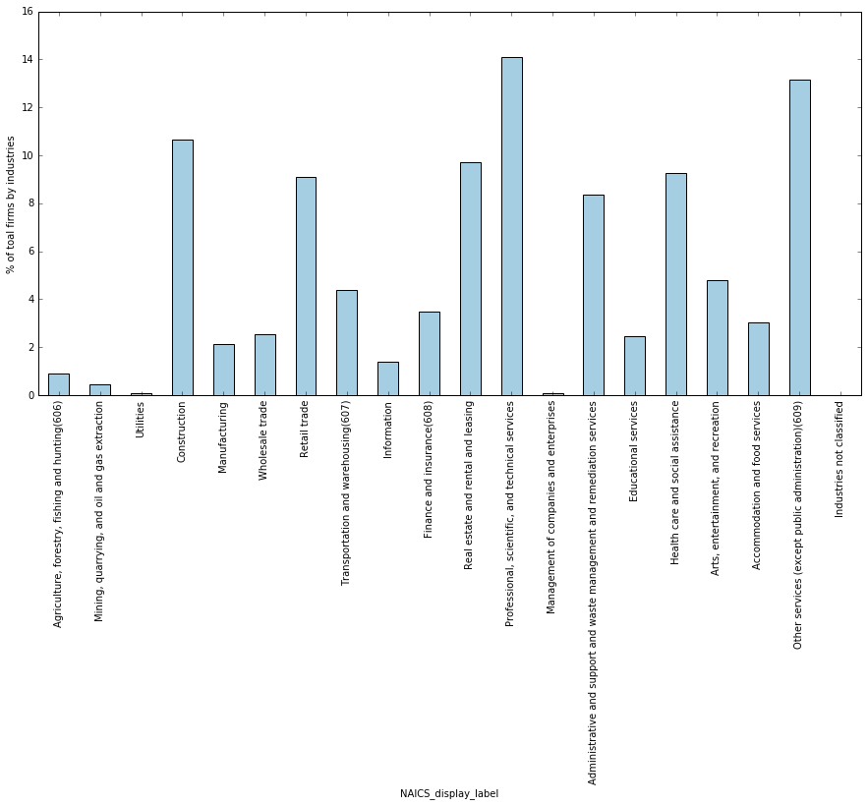

1. **What are the RICHEST industries in USA (2012) by sales, receipts, or value of shipments?**

The Wholesale trade sector/industry stands out with the highest percentage of “all firms’ sales, receipts, or value of shipments which is predictable, although an average person impression would probably be Finance and Insurance. However, the second richest industry - not far behind the first one is ... Manufacturing and that was surprising, since the impression given by mainstream media is that manufacturing had been shipped abroad. Well, some polls [[4]](http://www.gallup.com/poll/185927/americans-trust-media-remains-historical-low.aspx) suggest that trust in mass media in US is at its historical low, especially among younger people**[2]**. I recommend they hire more data scientists to fix the problem.

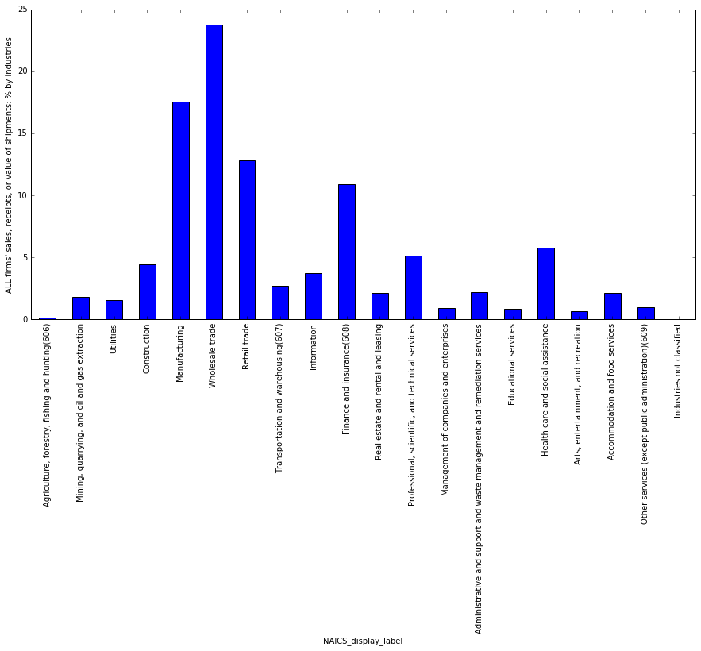

1. **Which industry's average percentage of companies with paid employees is the highest/the lowest?**

The lowest % of companies with paid employees happen to be Agriculture, forestry, fishing and hunting (606). It is difficult to speculate on the reasons why this is the case: it might be that a lot of farms are owned by families, that usually do not employ other people. From other side, in agriculture, forestry, fishing and hunting one can employ a lot of students and illegal immigrants. If the latter is true, then practically undocumented workers are low paid employees that simply are not reported as employees at all.

The highest % of companies with paid employees is Management of companies and enterprises. As an employer you might never find fools who would manage your other employees for FREE!

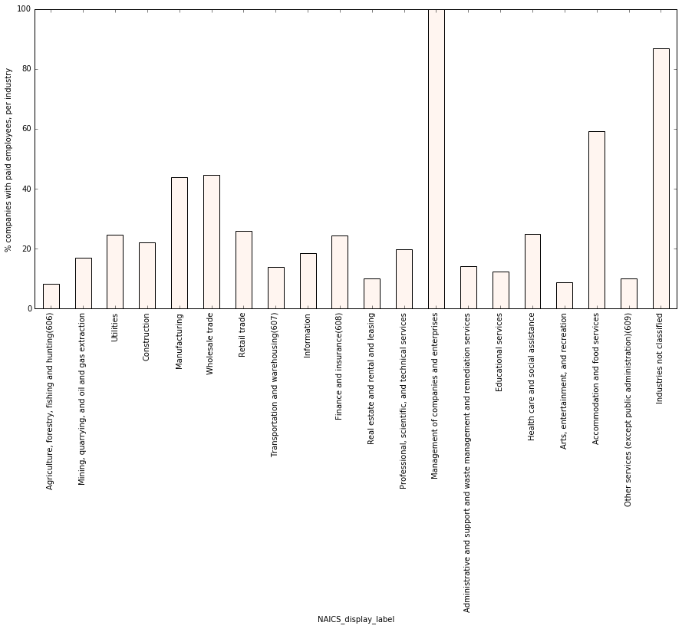

1. "The Accommodation and Food Services sector comprises establishments providing customers with lodging and/or preparing meals, snacks, and beverages for immediate consumption. The sector includes both accommodation and food services establishments because the two activities are often combined at the same establishment."
2. Stunning 36% trust in media in 2015 compared to 55% in 2001